Decay Rates
$$dN=-ΓNdt, N\left(t\right)=N\left(0\right)e^{-Γt}=N_{0}e^{-Γt}.$$
Stoichiometry
$$N\left(t+dt\right)=N_{0}e^{-Γ\left(t+dt\right)}=N_{0}e^{-Γt}e^{-Γdt}≈N_{0}e^{-Γt}\left(1-Γdt\right).$$
Number of particles that decay between $t$ and $t+dt$:
$$N\left(t\right)-N\left(t+dt\right)=N_{0}e^{-Γt}\left(1-1\left(1-Γdt\right)\right) \\ =N_{0}Γe^{-Γt}dt.$$
Fraction of particles that decay between $t$ and $t+dt$:
$$Γe^{-Γt}dt.$$
Probability that a given particle chosen at random will decay between $t$ and $t+dt$:
$$p\left(t\right)dt=Γe^{-Γt}dt$$

Mean lifetime
$$τ=\int_{0}^{∞}{tp\left(t\right)dt}=Γ\int_{0}^{∞}{\begin{aligned}{te}^{-Γt}dt=Γ{\left[t∙\left(-\frac{1}{Γ}e^{-Γt}\right)\right]}_{0}^{∞} \\ =\end{aligned}}-\int_{0}^{∞}{-\frac{1}{Γ}e^{-Γt}}∙1dt \\ =Γ{\left[t∙\left(-\frac{1}{Γ}e^{-Γt}\right)-\frac{1}{Γ^{2}}e^{-Γt}\right]}_{0}^{∞} \\ =\frac{1}{Γ}.$$

Half-life time
$$N\left(t_{1/2}\right)=\frac{1}{2}N_{o}=\frac{1}{2}N_{0}e^{-Γt_{1/2}}⟹e^{Γt_{1/2}}=2⟹t_{1/2}=τ\ln{2}.$$

Mean lifetime with different decay channels
$$Γ_{tot}=\sum_{i=1}^{n}{Γ_{i}}$$
and
$$τ=\frac{1}{Γ_{tot}}.$$

Branching ratio of $i$th decay mode
$$Br_{i}=\frac{Γ_{i}}{Γ_{tot}}.$$

Cross Sections
$$σ_{tot}=\sum_{i=1}^{n}{σ_{i}}.$$

Scattering
Scattering is characterized by cross sections.

Hard-sphere scattering
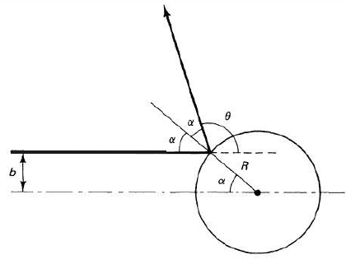
Imagine a particle bouncing elastically off a sphere of radius $R$. From the above figure, we have
$$b=R\sin{α, 2α+θ=π.}$$
Thus,
$$\sin{α}=\sin\left(π/2-θ/2\right)=\cos{θ/2}$$
and hence
$$b=R\cos{θ/2, θ=2\cos^{-1}\left(b/R\right)}.$$

Differential (scattering) cross section
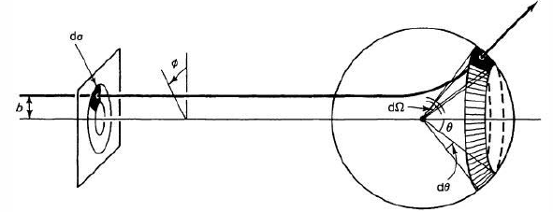
If the particle comes in with an impact parameter between $b$ and $b+db$, it will emerge with a scattering angle between $θ$ and $θ+dθ$. More generally, if it passes through an infinitesimal area $dσ$, it will scatter into a corresponding solid angle $dΩ$. With $D\left(θ\right)$ being the differential (scattering) cross section, we have
$$dσ=D\left(θ\right)dΩ.$$
The name is poorly chosen, and is more apt for $dσ$ than to ${dσ}/{dΩ}$. We see from the figure above that
$$dσ=\left|b db dϕ\right|, dΩ=\left|\sin{θ}dθ dϕ\right|.$$
Thus

$$D\left(θ\right)=\frac{dσ}{dΩ}=\left|\frac{b}{\sin{θ}}\left(\frac{db}{dθ}\right)\right|.$$

For the hard-sphere problem:
$$\frac{db}{dθ}=-\frac{R}{2}\sin\left(\frac{θ}{2}\right).$$
Hence,
$$D\left(θ\right)=\frac{Rb\sin\left(\frac{θ}{2}\right)}{2\sin{θ}}=\frac{R^{2}}{2}\frac{\cos\left(θ/2\right)\sin\left(θ/2\right)}{\sin{θ}}=\frac{R^{2}}{4}$$
using a half-angle formula for $\sin{θ}$. Hence
$$σ=\int{\frac{R^{2}}{4}dΩ=πR^{2}}.$$

For Rutherford scattering
A particle of charge $q_{1}$ scatters off a stationary particle of charge $q_{2}$. See Goldstein, Classical Mechanics, 3rd edition. From the cited source, the formula relating the impact parameter to the scattering angle is given by
$$b=\frac{q_{1}q_{2}}{4E}\cot\left(\frac{θ}{2}\right).$$
The differential cross section is therefore
$$D\left(θ\right)={\left(\frac{q_{1}q_{2}}{4E\sin^{2}\left(θ/2\right)}\right)}^{2}.$$
Then
$$σ=2π\left(\frac{q_{1}q_{2}}{4E}\right)\int_{0}^{π}{\frac{1}{\sin^{4}\left(θ/2\right)}}\sin{θ dθ=∞.}$$

Luminosity
Luminosity, $L$, is the number of particles passing down the beam line per unit time per unit area. Consider a beam of particles, with uniform luminosity. Then $dN=Ldσ$ is the number of particles per unit time pass through area $dσ$, and hence also the number per unit time scattered into solid angle $dΩ:$
$$dN=Ldσ=LD\left(θ\right)dΩ.$$
If we set up a detector that subtends a solid angle $dΩ$ with respect to the collision point (see figure on next page)
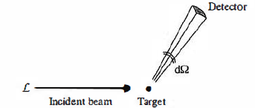
The even rate is the number of particles per unit time, $dN$, reaching the detector. Experimentalists determine the solid angle, and the accelerator controls the luminosity. We obtain
$$\frac{dσ}{dΩ}=\frac{dN}{LdΩ}.$$
If the detector surrounds the target, then $N=σL.$

